About AHG
AHG Mission Statement

Building women of integrity through service to God, family, community and country.

AHG Oath

“I promise to love God,
Cherish my family,
Honor my country,
And Serve in my community.”

AHG Creed

As an American Heritage Girl, I promise to be:

Compassionate Understanding others in fellowship, empathy, kindness, and caring. Respect others’ opinions and emotions.
Helpful Willingly serve others.
Honest Always tell the truth and keep my promises.
Loyal True to God, family, friends, community and country.
Perseverant Continuing to strive toward a goal despite obstacles.
Pure Keep my mind and body pure.
Resourceful Wisely use my time, materials and talents.
Respectful Honor my country, be obedient to those in authority, and courteous to all.
Responsible Accountable for my own actions. Reliable in all situations.
Reverent Faithful and honoring to God. Respectful to the beliefs of others.

Statement of Faith

American Heritage Girls is a Christ-centered leadership and character development ministry. Within the local AHG Troop, the primary statement/profession of Christian beliefs, faith, and/or doctrine is that belonging to the chartering Church/Organization. As with any of its ministries, the Church/Organization should take steps to ensure the Troop appropriately reflects these beliefs. Furthermore, all American Heritage Girls’ Charter Organizations, Adult Members and Adult Leaders, must concurrently adhere to the Christian principles stated in AHG’s Statement of Faith:

We believe that there is one Triune God – Father; Jesus Christ, His one and only Son; and the Holy Spirit – Creator of the universe and eternally existent. We believe the Holy Scriptures (Old and New Testaments) to be the inspired and authoritative Word of God. We believe each person is created in His image for the purpose of communing with and worshipping God. We believe in the ministry of the Holy Spirit, Who enables us to live Godly lives. We believe that each individual is called to love the Lord our God with all our heart, mind, soul and strength; and to love our neighbors as ourselves. We believe God calls us to lives of purity, service, stewardship and integrity.

Clarity is further provided to the following terms:

Purity – God calls us to lives of holiness, being pure of heart, mind, word and deed. We are to reserve sexual activity to the sanctity of marriage; a lifelong commitment before God between a man and a woman.
Service – God calls us to become responsible members of our community and the world through selfless acts that contribute to the welfare of others.
Stewardship – God calls to use our God-given time, talents and money wisely.
Integrity – God calls us to live moral lives that demonstrate an inward motivation to do what is right, regardless of the cost.

American Heritage Girls’ Inclusion Policy:

All biological girls of any color, race, national origin and socioeconomic status who agree to live according to the standards of the AHG Oath and the AHG Creed are invited to be a member of American Heritage Girls.

Troop Structure

“Just as a body, though one, has many parts, but all its many parts form one body, so it is with Christ.” 1 Corinthians 12:12, NIV
Just as the scripture above demonstrates, the body of Christ requires each one to come together in the Kingdom of God, the same is true in the Troop structure. The Troop Board is made up of five positions that are selected by the Charter Organization and entrusted with implementing the mission of building women of integrity. Because of their influence and focus on establishing goals for the Troop, the selection of Troop Board Members is crucial to ensure that the right people are serving on the Troop Board. The Troop Board represents their Charter Organization and AHG, Inc. to Troop families and the local community. Each position has its own volunteer ministry description which outlines the responsibilities and qualifications for the position. To protect the integrity of the Troop’s decision-making process, the Troop Board Members should not be related to one another. If the Charter Organization has any questions or concerns about the Troop Board structure, please discuss them with your Hometown Mentor or Troop Coach.

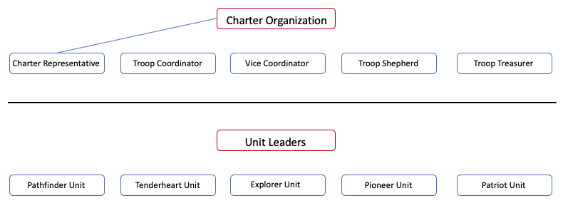

The Troop Board works together as a team to provide direction and make decisions on behalf of the Troop. One of the most impactful ways the Troop Board leads is through prayer. The Troop Board Members together and individually pray for the Charter Organization, the Troop, the girls, their families, and the community. The Troop Board is made up of:
- Charter Representative
- Troop Coordinator
- Vice Coordinator
- Troop Shepherd
- Troop Treasurer
The Troop Ministry Team functions together to fulfil the mission of building women of integrity. The team is comprised of the Troop Board, Unit Leaders, and Assistant Unit Leaders. Unit Leaders and Assistant Unit Leaders along with the Troop Board play an integral part in implementing the AHG Program and ministering to girls in the Troop. The number of Unit Leaders and Assistant Unit Leaders will vary year to year, based on the number of girls within the Troop. The Troop Ministry Team is made up of:
- Charter Representative
- Troop Coordinator
- Vice Coordinator
- Troop Shepherd
- Troop Treasurer
- Unit Leader
- Assistant Unit Leader

AHG Program
The AHG Program is built around six Program Emphases to achieve the mission of building women of integrity. These six key components create a Christ-centered, progressive, and balanced structure, providing girls with a holistic experience. AHG’s goal for a girl who completes the AHG Program is that she has learned to be a Christ-following servant leader who is honoring, relational, anchored in Christ, and competent: a woman of integrity.

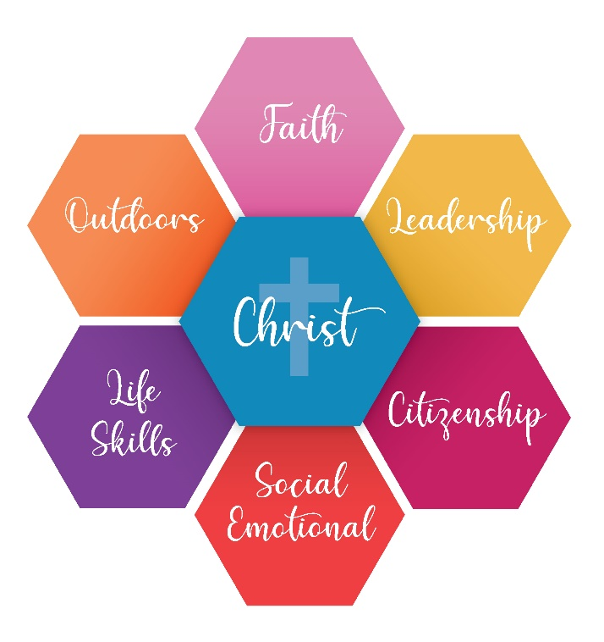
Faith
Girls are encouraged to grow in their faith and relationship with God through the AHG Faith Award Program, prayer, fellowship, and service, which are woven throughout each aspect of the AHG Program.
Outcome: A Christ-follower who submits to Christ and seeks God’s will for her life.
Leadership
The AHG Program is rich in leadership opportunities for girls of all ages. Girls discover their passions, acquire project management skills, hold leadership positions, and participate in leadership training.
Outcome: A servant leader who follows Jesus’ model of leadership by putting others first.

Citizenship
The AHG Program provides girls with a deeper understanding of their country and heritage. Girls cultivate honor for their country by participating in patriotic events, flag ceremonies, serving in their community, and through badge work. Serving others and being active citizens with their Troop, fosters a lifelong love for their country.
Outcome: An honoring girl who cares for her community as an active citizen through service and patriotism.
Social & Emotional
Girls will gain a better understanding of their identity in Christ through the AHG Program. AHG’s multi-level Troop structure encourages girls to create friendships with girls of all ages. This unique Troop structure allows for mentorships and learning opportunities to occur naturally among girls. Girls learn to anchor their emotions in Christ in a caring and loving environment.
Outcome: A relational girl who invests in positive and loving relationships with others and clings to Christ when navigating emotions.
Life Skills
In the AHG Program, girls can step out of their comfort zone and try new experiences in a safe environment. Earning badges provides girls the opportunity to learn a wide array of life skills, inspiring them to become lifelong learners and doers. AHG’s six Badge Frontiers include: Heritage, Family Living, Arts, Outdoor Skills, Personal Well-Being, and Science Technology.
Outcome: A competent girl who enjoys mastering new skills and applies them to her life.
Outdoors
Nature reveals to us God’s beauty, glory, power, wisdom, presence, creativity, and, most of all, his loving care. Through the AHG Program, girls are encouraged to participate in outdoor activities such as hiking or camping several times a year. High Adventure activities are great times for team building, leadership, physical activity, and strengthening relationships with friends. The outdoors will educate girls about their natural world and the beauty God has bestowed upon them.
Outcome: A girl who values creation through outdoor experiences that display the glory of God’s creation.
Girl and Adult Member Uniforms
AHG is a uniformed organization which creates a sense of belonging for both Girl and Adult Members. Girl and Adult Members will wear the AHG Official Class A Uniform to the majority of AHG activities. The AHG Official Class B Uniform is utilized for more casual activities. Uniforms, handbooks, and other AHG merchandise can be purchased through the AHGstore: store.americanheritagegirls.org
Contact your Troop Board for more information about uniforms.

Awards and Recognition
AHG provides numerous opportunities for girls to grow by earning awards and recognitions. Although not the focus of the Program, they serve as a tool to recognize girls as they grow into women of integrity.
Awards and insignia that AHG offers is listed below:
- Joining Award
- Level Awards
- Faith Awards
- Stars & Stripes Award
- Service Stars
- Badges
- Patches
- Sports Pins
AHG also recognizes the immense value of volunteers by offering tenure pins and other recognitions for their investment in girls and the AHG Ministry.
Award Ceremonies

The Troop plans Award Ceremonies throughout the year so Girl and Adult Members may receive their Awards and Recognitions. Award Ceremonies are open to parents/legal guardians and families to attend. It is important to the girls that family attend the ceremony to celebrate their accomplishments. If a girl is unable to attend the ceremony, her recognition will be given to her at the next Troop meeting.

